CYBR 3510 "Systems Security"

1. Create a new account with the account name ‘CYBR3510’@’localhost’ identified by a password ‘systemsecurity’. 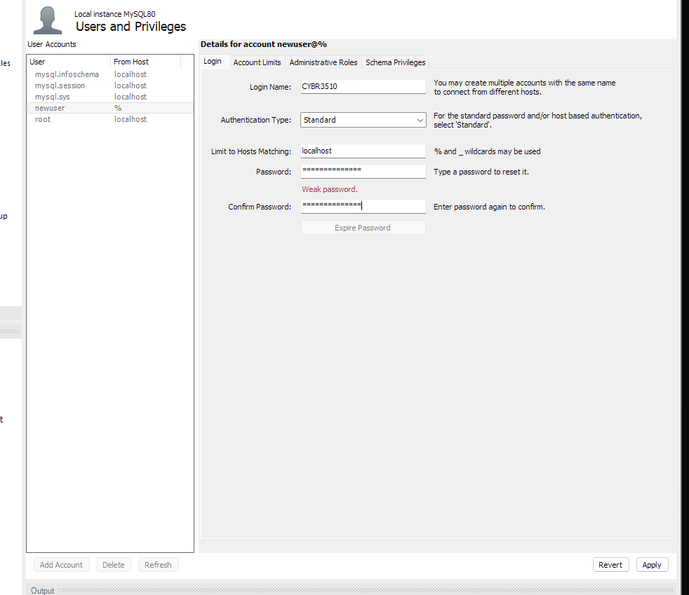
2. Create another connection with ‘CYBR3510’ user account. As the ‘CYBR3510’ user, can you use the Kimtay Database? (i.e., execute the “use Kimtay;”) A screenshot of a computer

   Description automatically generated
3. Use the ‘root’ user to grant column level permissions so that the ‘CYBR3510’ user can only select the cust_id and rep_id in the kimtay.customer table. Now check the cust_id and rep_id in the kimtay.customer table as the ‘CYBR3510’ user. Can the ‘CYBR3510’ user check the first_name and last_name listed in the kimtay.customer table? 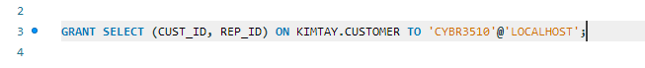
4. Use the ‘root’ user to grant table level permissions so that the ‘CYBR3510’ user can only select the customer table in the kimtay database. Use the ‘CYBR3510’ user to return everything in the customer table. Use the ‘CYBR3510’ user to return everything in the sales_rep table and see if it succeeds. A white rectangular sign with black text

   Description automatically generated
5. Use the ‘root’ user to grant database level permissions so that the ‘CYBR3510’ user can only select the kimtay database. Use the ‘CYBR3510’ user to return everything in the sales_rep table and check if it succeeds. Use the ‘CYBR3510’ user to return everything in the office table of the staywell database and see if it succeed.

1. Use the ‘root’ user to grant global level permissions so that the ‘CYBR3510’ user can select everything. Use the ‘CYBR3510’ user to select everything in the msql.columns_priv table and check what column level privileges have been granted in the system. (if this operation fails, refresh the connection)

1. Use the ‘root’ user to grant database level permissions so that the ‘CYBR3510’ user can select the kimtay database with grant option. Create another user ‘user1’@’localhost’ identified by ‘123456’ and ‘user2’@’localhost’ identified by ‘123456’. Make new connections for ‘user1’ and ‘user2’.

1. Use the ‘CYBR3510’ user to grant the select permission on kimtay database to ‘user1’@’localhost’. Check if ‘user1’ can access the kimtay database. Then, use the ‘user1’ to grant the select permission on kimtay database to ‘user2’@’localhost’ and see if it succeeds. A white rectangular sign with black text

   Description automatically generated
2. Use the ‘root’ user to revoke the select and grant permission on kimtay database from ‘CYBR3510’@’localhost’. Check if ‘CYBR3510’ and ‘user1’ can still access the kimtay database. A close up of a sign

   Description automatically generatedA white rectangular sign with black text

   Description automatically generated
3. Revoke all the privileges of ‘CYBR3510’ so that it cannot access anything.

